**Comp1168-Group Project (Mountain Valley Community Hospital-MVCH)**

**Marks 30%**

**DUE DATES:**

**Part 1 March 25-Midnight**

**Part 2 March 29-Midnight**

**Part 3 April 2-Midnight**

**Part 4 April 8-Midnight**

**Part 5 April 15 -Midnight**

**Like I said, There are different due dates for each part because one part flows into the other parts, so this way the dates are more or less equal.**

**Pick one part (unless anyone wants to do more than one part) and let me know which part you would like to do. I’m going to let it be first come, first pick.**

**When you’re done your part, email me it to me, and then I’ll email it to the next person. IF you’re done your part early, feel free to email early as well ☺**

**I put some additional notes on the last part as well (in the green) .**

**Comp1168-Group Project (Mountain Valley Community Hospital-MVCH)**

**Marks 30%**

The Group Project is to be done by a group of maximum FIVE (5) students. You may include students from the other section in you group

The project is due on Wednesday April 17

Please submit a hard copy during the class time on April 17th.

**Please refer to the description of the MVCH Case study in your text book and the following ERD and Business rules for MVCH and answer the FIVE questions.**

**ER Model for Mountain View Community Hospital**

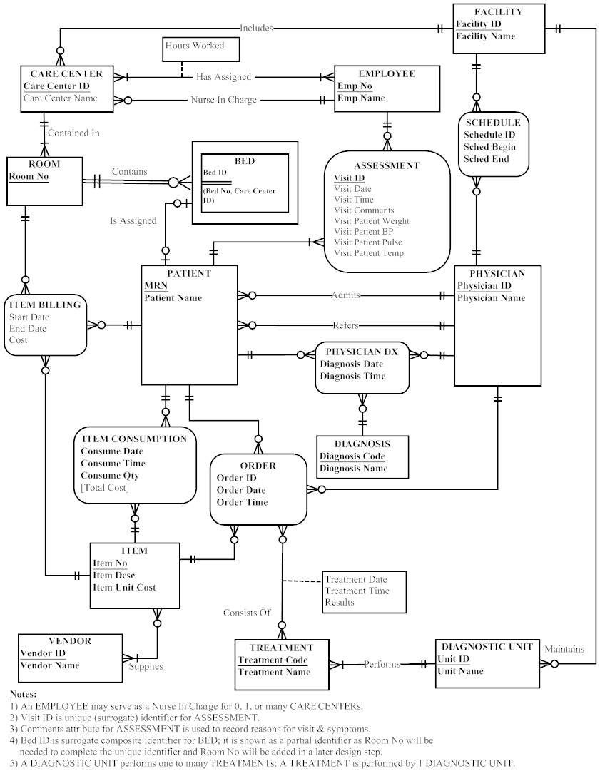

**Business Rules**

A FACILITY can contain one or more CARE CENTERS or may contain no CARE CENTERS. A CARE CENTER is part of one and only one FACILITY.

A FACILITY may maintain one or more DIAGNOSTIC UNITS or may maintain no DIAGNOSTIC UNITS. A DIAGNOSTIC UNIT is part of only one FACILITY.

A CARE CENTER has many EMPLOYEES. Each CARE CENTER has one EMPLOYEE assigned as a nurse in charge. Each EMPLOYEE may work for one or more CARE CENTERS.

A CARE CENTER will contain one or more ROOMs. Each ROOM is contained in only one CARE CENTER.

A ROOM may contain one or more beds or may contain no BEDS, A BED is contained in only one ROOM.

A DIAGNOSTIC UNIT performs one or more TREATMENTS. A TREATMENT is performed by only one DIAGNOSTIC UNIT.

A BED is assigned to one patient or no patients. A PATIENT is assigned to one BED or no BEDS.

A PHYSICIAN admits one or more PATIENTS or admits no PATIENTS. A PATIENT is admitted by only one PHYSICIAN.

A PHYSICIAN may refer one or more PATIENTS or may refer no PATIENTS. A PATIENT must be referred by one PHYSICIAN.

A PATIENT may consume many ITEMS or may consume no ITEMS. An ITEM is consumed by one or more PATIENTS or may be consumed by no PATIENTS.

An ITEM is supplied by one or more VENDORS. A VENDOR may supply one or more ITEMS or may supply no ITEMS.

A PHYSICIAN may write one or more ORDERS or may write no ORDERS for one PATIENT. An ORDER is written by one PHYSICIAN.

An ORDER may consist of one or more ITEMS or no ITEMS. An ITEM may be part of one or more ORDERS or may be part of no ORDERS.

An ORDER may consist of one or more TREATMENTS or no TREATMENTS. A TREATMENT may be part of one or more ORDERS.

A PHYSICIAN may complete one or more DIAGNOSES for one or more PATIENTS. A DIAGNOSIS is completed for one PATIENT by one PHYSICIAN.

A VENDOR may supply one or more ITEMs. Each ITEM may be supplied by more than one VENDOR.

An EMPLOYEE completes one, none, or many ASSESSMENTs of a PATIENT. Each PATIENT may have one or many ASSESSMENTs over time at this hospital.

A FACILITY may prepare multiple staffing schedules for its PHYSICIANs. Each SCHEDULE instance is for a single FACILITY and a single PHYSICIAN. A PHYSICIAN may have zero, one, or many SCHEDULEs.

**Project Assignments**

1. Create a relational schema for MVCH. Make sure that all relations are in 3NF and underline the primary keys, include all foreign keys for all relations and clearly indicate the referential integrity constraints. Chapter 4 and extra post on blackboard
2. Create a Data Dictionary (use the Metadata Table1-1 in chapter 1 as a template) for the MVCH database. Chapter 1, slide 6
3. Create an SQL Script containing CREATE TABLE commands that would create all tables with primary, foreign keys and proper data types for table attributes. Also create relationships between tables as shown in the ERD. Write in text pad, with the extension of .sql
4. Insert some sample data in your tables. Again write in text pad, with the extension of .sql
5. Create the following queries (Use any tables and data of your choice)—Provide the SQL statements in your project report and also include the result set (copy the clipboard Image from SQL Management Studio). . Again write in text pad, with the extension of .sql, From chapter6 and additional slides Abid will post on blackboard. Also some of these do not apply very well but your to make them fit as best as possible.
   1. Create a SELECT query that uses a condition in the WHERE Clause.
   2. Create a SELECT query that uses an Aggregate function.
   3. Create a SELECT query that includes an ORDER BY Clause.
   4. Create a SELECT query that includes an GROUP BY and HAVING Clauses.
   5. Create a VIEW that is based on at least THREE Tables.
   6. Create a SELECT query that includes an OUTER JOIN
   7. Create a SELECT query that includes a sub-query.
   8. Create a SELECT query that uses a Self Join.
   9. Create a SELECT query that uses the CASE conditional structure.